Report

***The Secret Power –***

***Anonymous Community***

Submitted By: **Juned**

For the award of the degree of: **Bachelor of Computer Application**



**Hindu Institute of Management**

Hindu Institute of Management, Near Railway Station Road,

Rohtak Road, Sonepat – 131001 Delhi - NCR

Mobile :- 08901440704 , 08901440705

### Ref: <https://indiaclass.com/project-report-index-format/>

**Chapter 1: (Introductory)**

### Executive Summary:

* **Introductory**: The Secret Power is the community where people & individuals have a right to say anything without judgment. It gives users freedom of speech.
* **Background of the Study:** Most of people don’t have any platform to say their thought independently.
* **Key Objectives:**People can express their thought & knowledge with & without reveal their identity loss.
* **Methods Used**: Used diff programing languages with help of developers.
* **Findings**: Finding solution of their project based on google research & YouTube tutorials.
* **Suggestions (or Recommendations)**: We need this to change the world.

1. **Origin Story**

As a professional digital marketer carrier. I observed people don’t have freedom of speech.

**Surprising?**

**Case 1:**

**Your thought is not visible to everyone if this is not good for any profile.**

* Suppose you purchased a product on Our website like **IMARS FASHION** Which is made by me A eCommerce store that sells luxury Handbags.
* You don’t like the product & service behavior whatever issue with workmanship & Customer Support.
* You will go through the product page & gives a review & also write their google business page & explain your issue with this brand.
* Believe me, if the owner & manager of the website won’t like your feedback & review he will remove this from the website.
* This is how the internet works.

**Case 2:**

**Your Video Streaming will no longer if this harm any individual or company even it’s**

**Truth or false.**

* YouTube is a privately owned company that governs some rules of its own & govt. So they have full right to remove your content they have made strict guidance for the creator. They can directly remove content even your Youtube Channel to.

### Introduction

* Title of the project: Secret Power (Anonymous Community)
* Background or need of the project:
* We must need any kind of platform where we have freedom of right even it’s true or False.
* We just want share our observation of mindset independently.

1. **Key objectives & scope of the project**

* **Freedom of thoughts:** Freedom of the thoughts is the biggest power in the world, Doesn't matter who you are?, where are you?
* **Throw out lies**: Sometimes we are suppressed by the people who have more power, Who have more money. But our community will welcome everyone. Everywhere, Every time they share their thoughts without any fear.

1. **Information about topic**

* A strong advocate of Satya (Truth) and Ahinsa (non-violence), Gandhi showed the power of love and non-violence in combating injustice and oppression. Mahatma is the title given to this inspiring personality who led the masses with his optimism, courage, his principles, and practice
* **Mahatma Gandhi ji said** "**Freedom is not worth having if it does not include the freedom to make mistakes".** And he gave us the **sweetest gift which was freedom of thought**, but somewhere today we are losing it, we are losing it because, Some people who have money, some people who have power. Those people are suppressing people with their power and money. That's why now there is a need for a platform where we can all share our thoughts, where no one is big or no one is small. Those people have gone wrong with them, those people who want to tell their truth, our community will welcome everyone. Everywhere, Every time.

1. **Project Description**

* One of the most disadvantages of the similar apps is limited users can join similar groups. But the Secret Power will be quite different. We don't need to create groups as here all Matters will be identified by the Hashtags.
* The biggest specification of the “The Secret” will be? Yes of course! Secret. Now here you are completely safe. We won’t let them know about your real name and your real identity. Any user can login here by their Mail ID. No one will be able to see about your identity.
* You can post your thoughts on any people, Any politician, Any place, Any Country, Or any organization.
* **Categories Created**
* Social Life
* Personal Life
* Corporate
* Personal Secret
* Friends Secret
* Strange things

1. **Privacy**

* It is not just the secret Posts of Secret Power that guarantee greater security in the app, since all the content uploaded by the user only will be deleted and uploaded by the user only who has uploaded the content. We will not have any traceable identity where a user can be traced, there will not be any name and profile picture. The thing which will be named as “Anonymous” & profile picture will be the avatars which do not have any real existence.

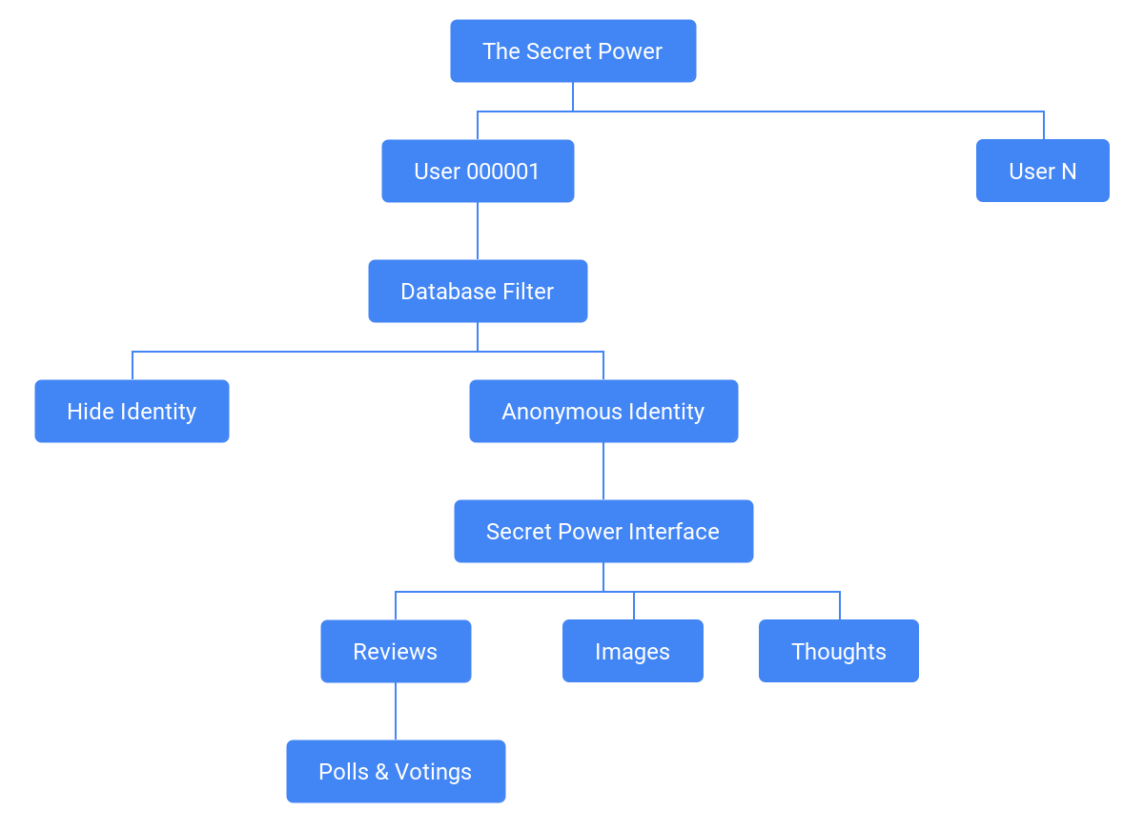

### Chapter 2: Objectives of the Study

**1. Literature Review?**

* **Benjamin Franklin:** Without freedom of thought, there can be no such thing as wisdom - and no such thing as public liberty without freedom of speech.
* **Tom Smothers:** Freedom of expression and freedom of speech aren't really important unless they're heard. The freedom of hearing is as important as the freedom of speaking.
* **Larry Flynt:** Privacy is not explicitly spelled out in the Constitution as freedom of speech is in the First Amendment.

**2. Methodology?**

* Create Account: Create account using Email ID or Phone Number.
* Post Anonymousely: Share your thoughts anonymously.
* Admit Proofs: Now you have the power to share your views on any organisation, people, place with the proof.

### Chapter 3: Organization Profile

* Website Name: Secret power
* Website Origin: May 22
* Founder: Juned
* Founder Study: BCA Computer Science
* Vision: To give single entity to power to say what they want to say.

### Chapter 4: Theoretical & Practical Background

* **Review Of Literature**

First User will open the website like this.

We have made this user interface as simple so that nothing to explain on it.

**Website** [**Home Page**](../templates/index.html)

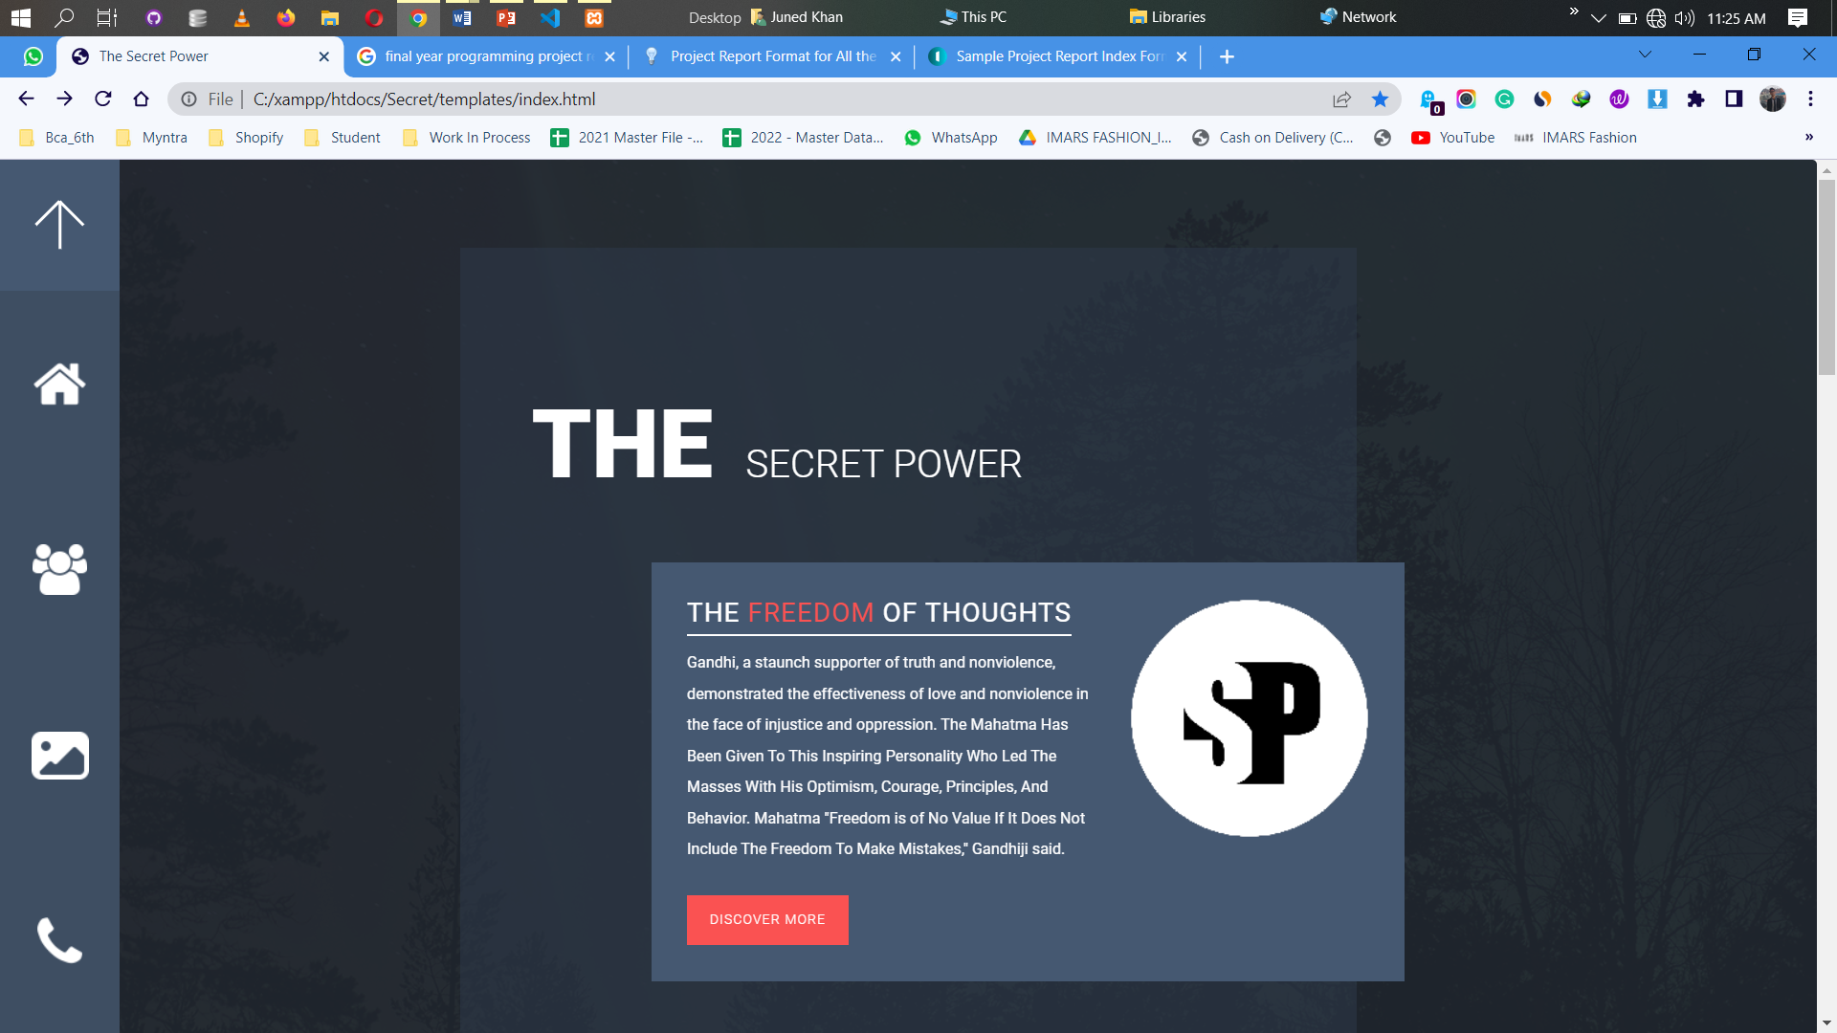

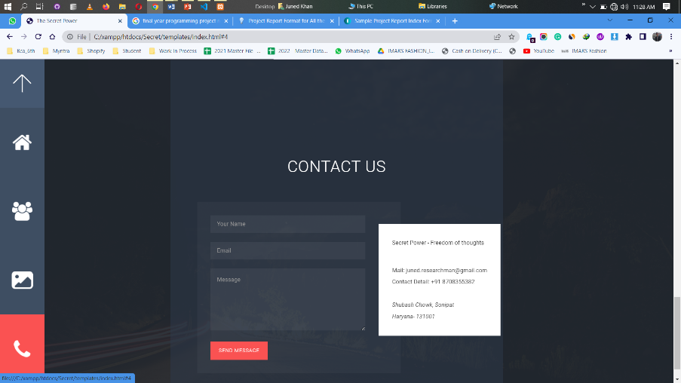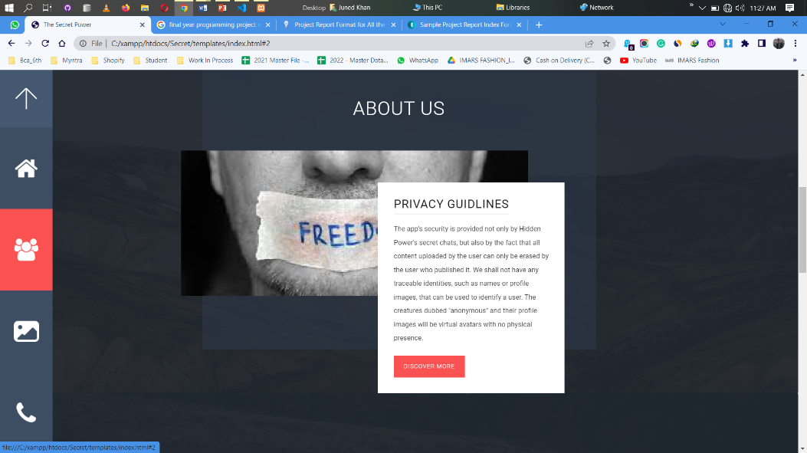

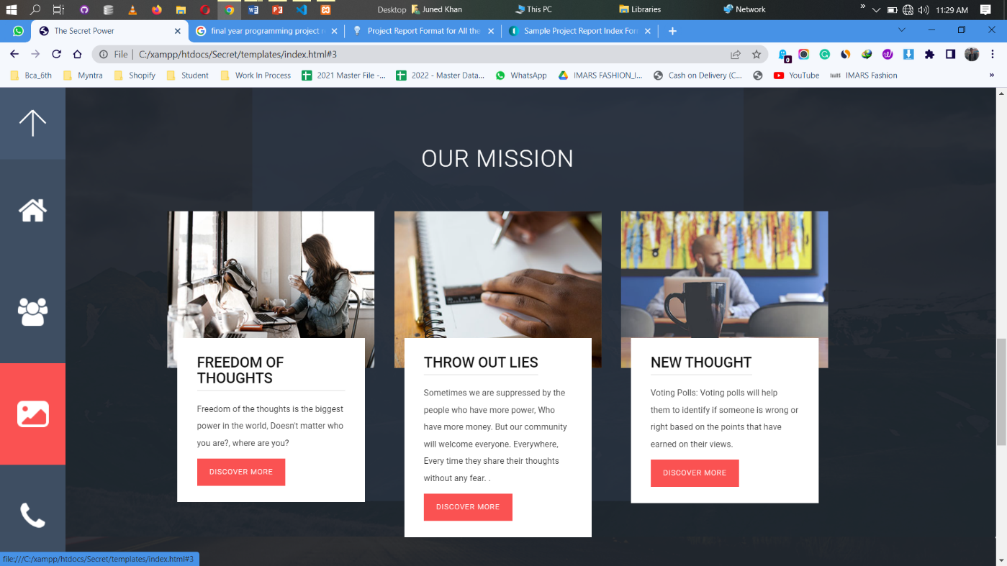

**In Homepage Have only 4 Pages.**

* Home
* About us
* Mission
* Contact Us
* **Fundamental Concepts**
* When User click on on Discover more in homepage he will redirect to Community Post.
  1. Website [Home Page](../templates/index.html)
  2. Website [Blog page](http://localhost/secret/)
  3. Sign in [Anonymously](http://localhost/secret/blogadmin/index.php?signIn=1)
  4. Website [Blog Admin](http://localhost/secret/blogadmin/index.php)
  5. Website [Database](http://localhost/phpmyadmin/index.php?route=/database/structure&server=1&db=blog_admin_db)
  6. Website [Source Code](../../Secret)

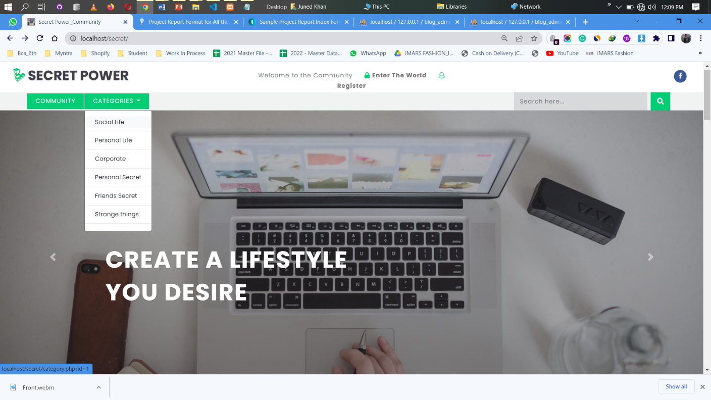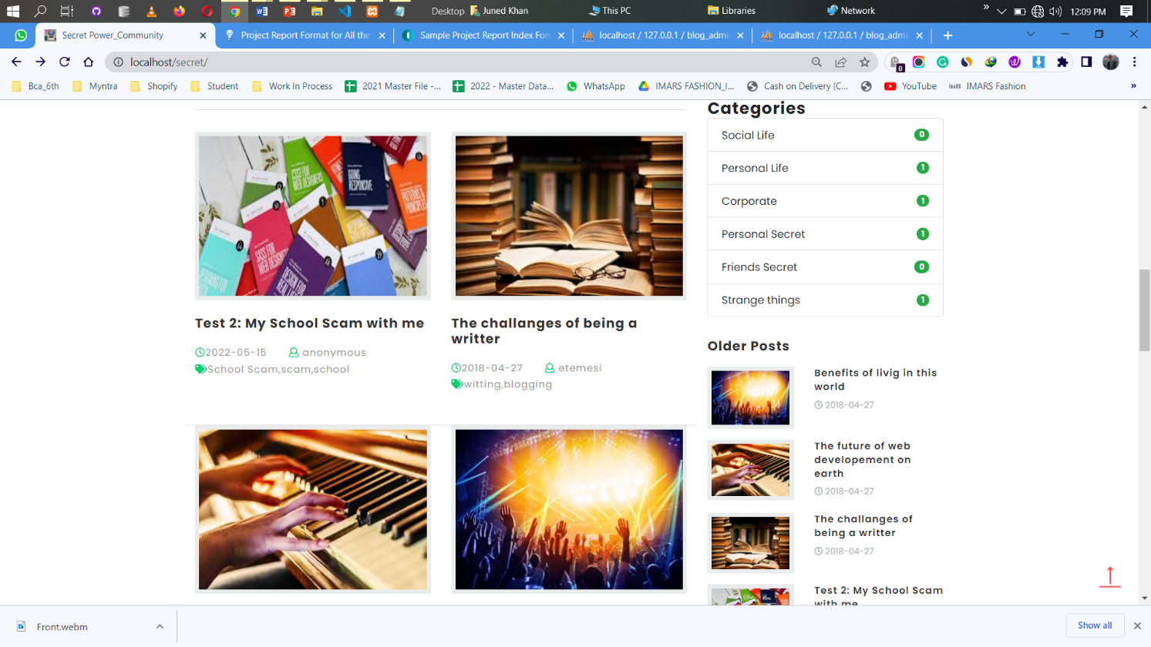2. Website [Blog page](http://localhost/secret/)

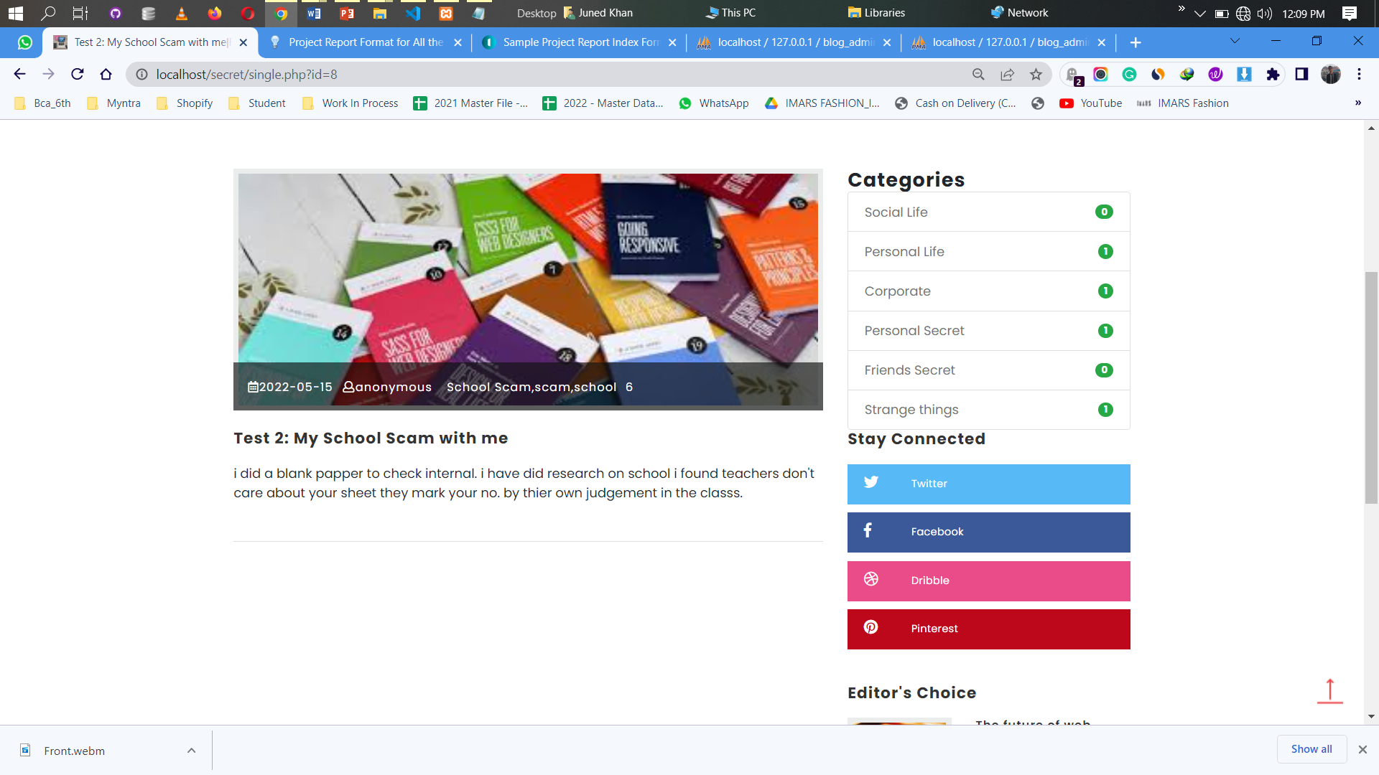

3. Sign in [Anonymously](http://localhost/secret/blogadmin/index.php?signIn=1)

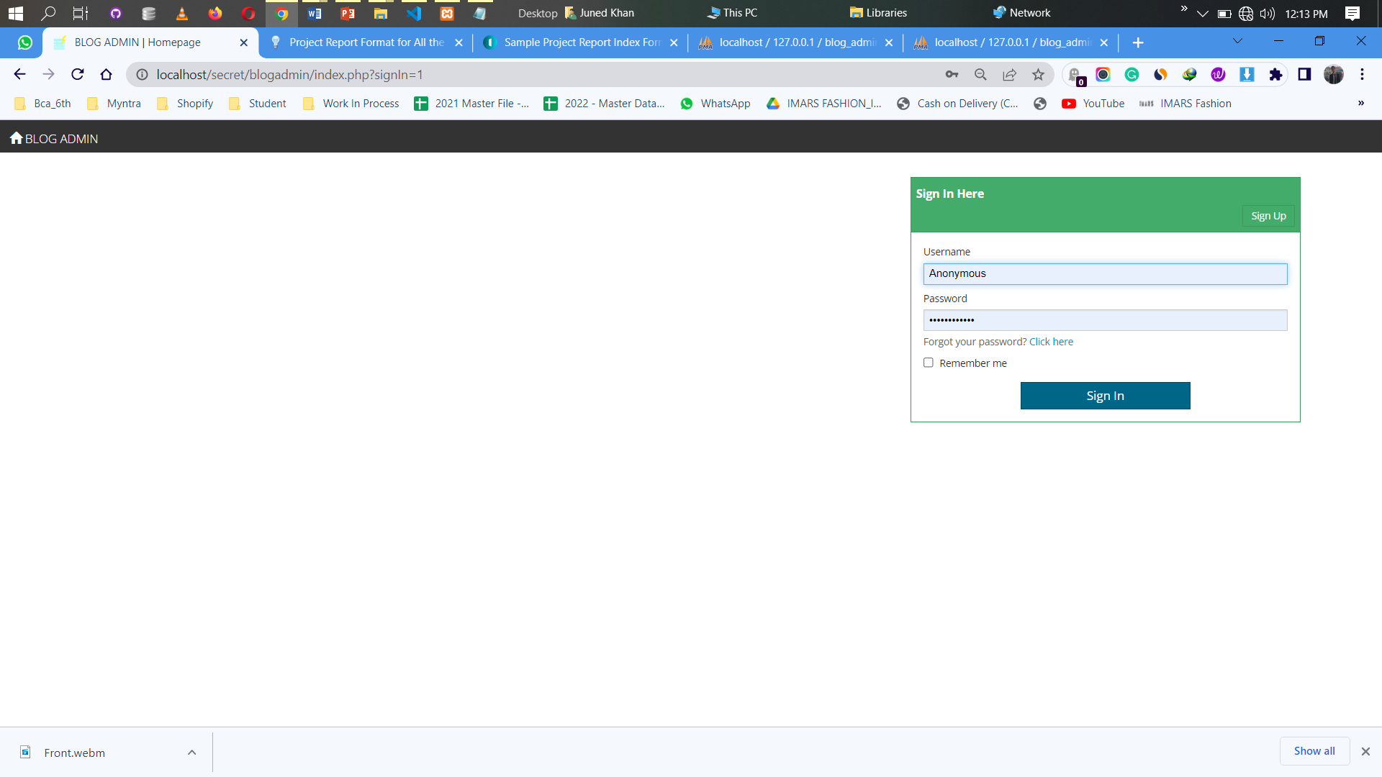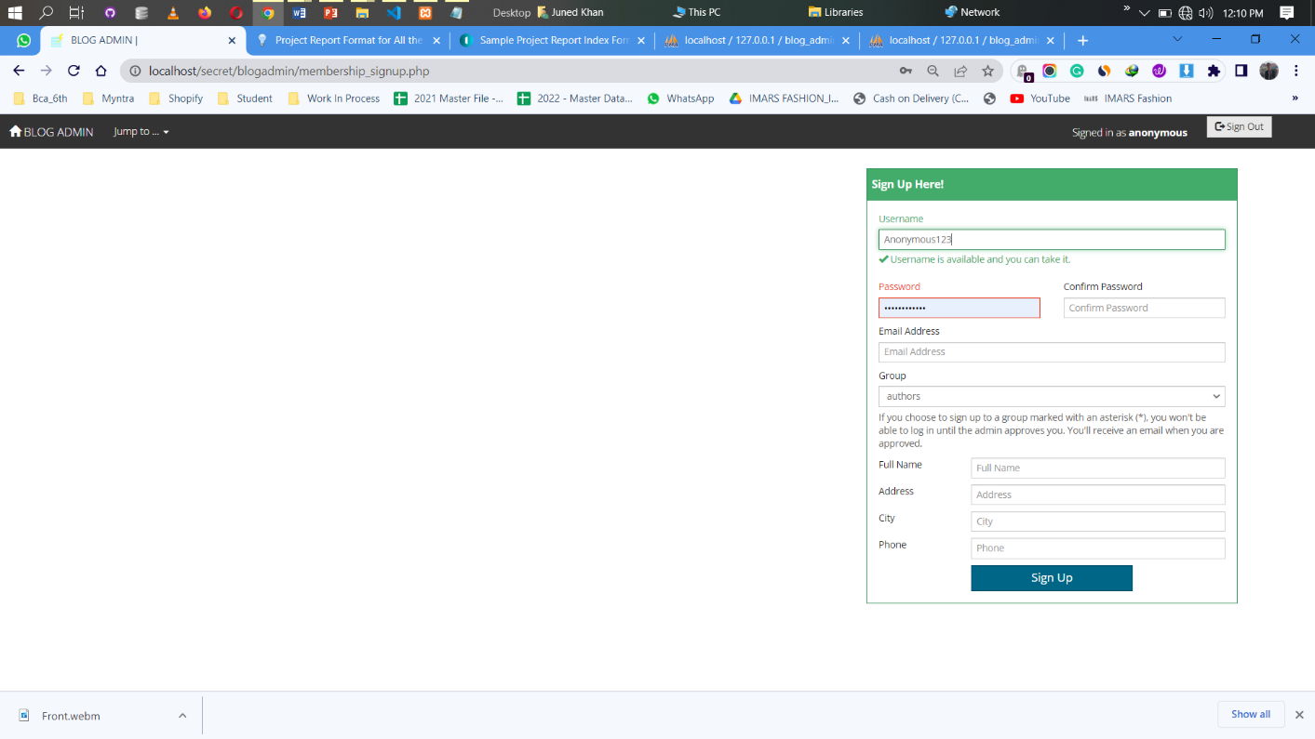

4. Website [Blog Admin](http://localhost/secret/blogadmin/index.php)

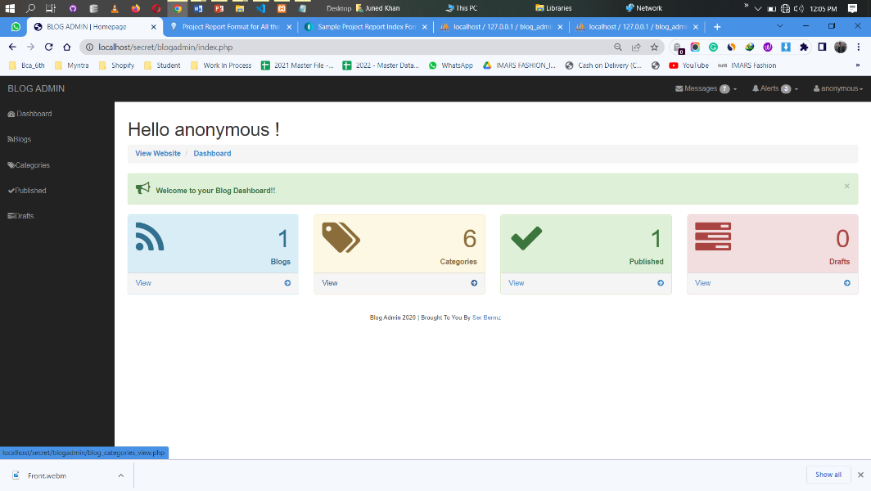

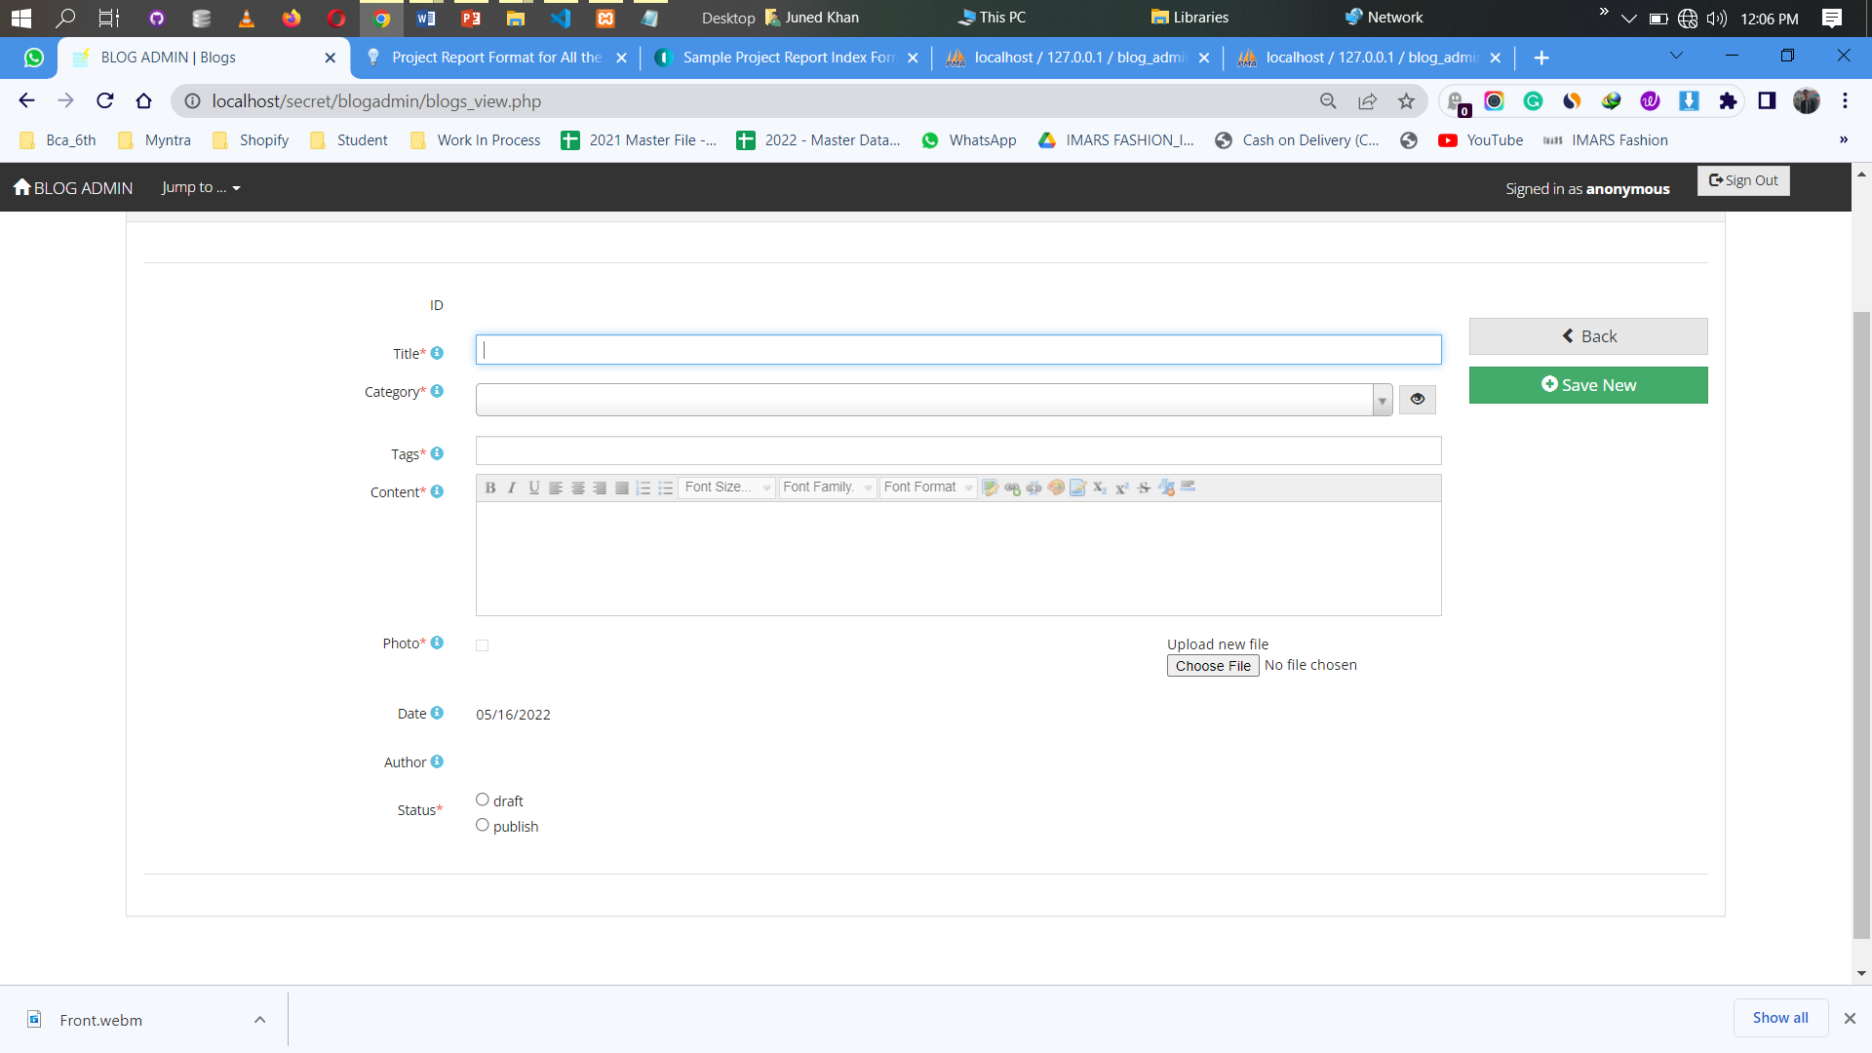

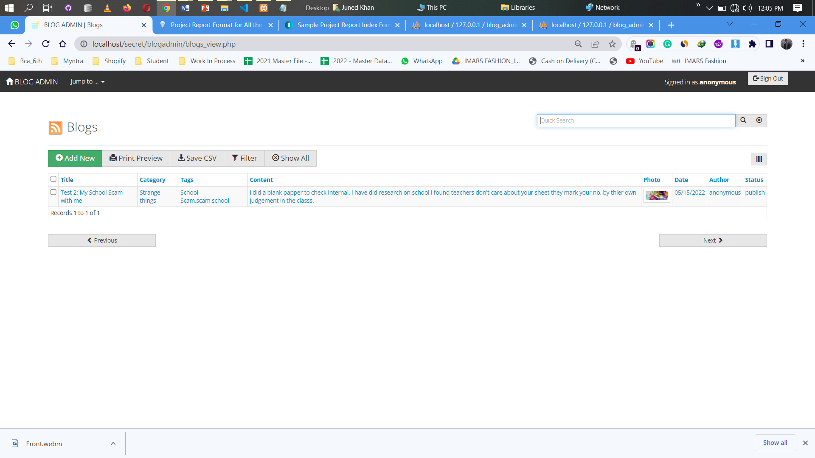

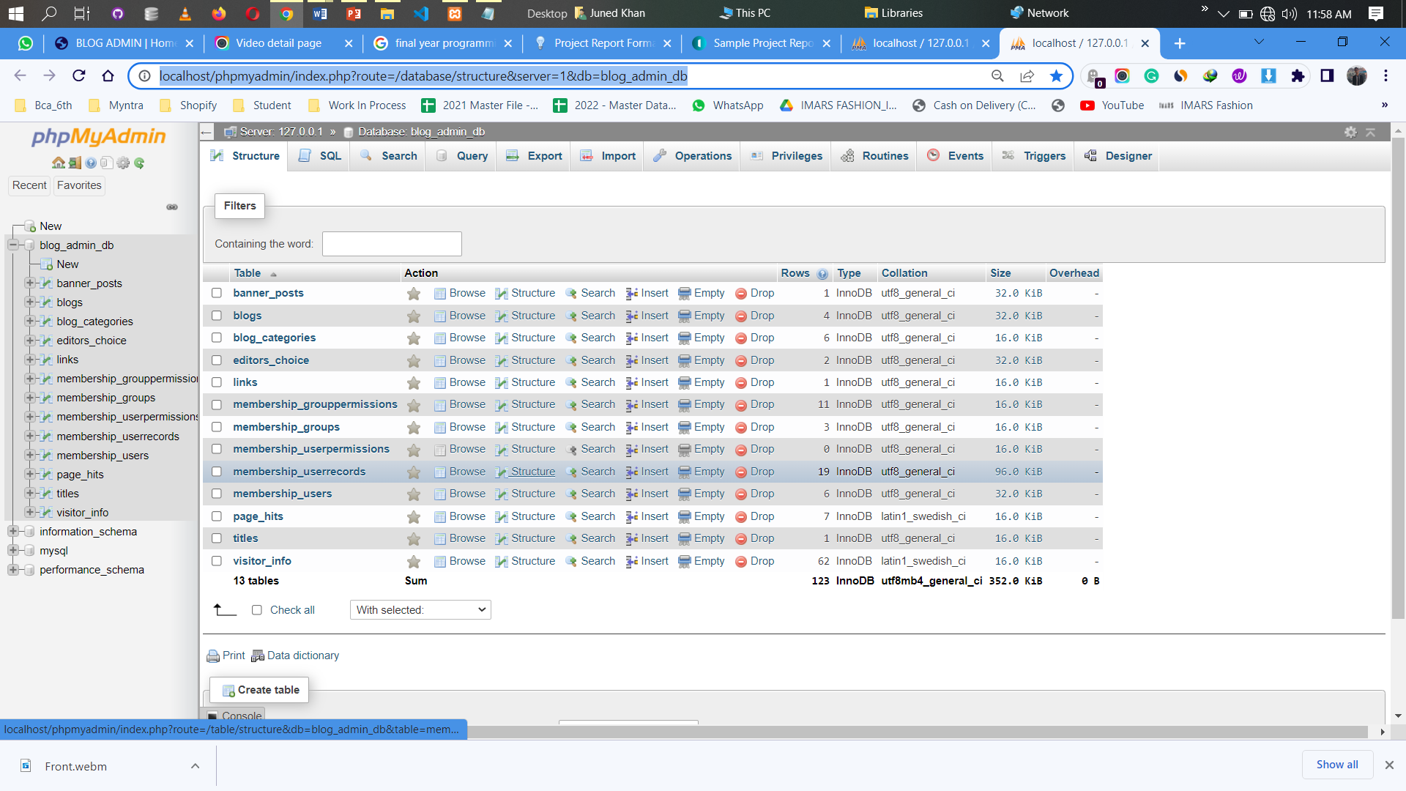5. Website [Database](http://localhost/phpmyadmin/index.php?route=/database/structure&server=1&db=blog_admin_db)

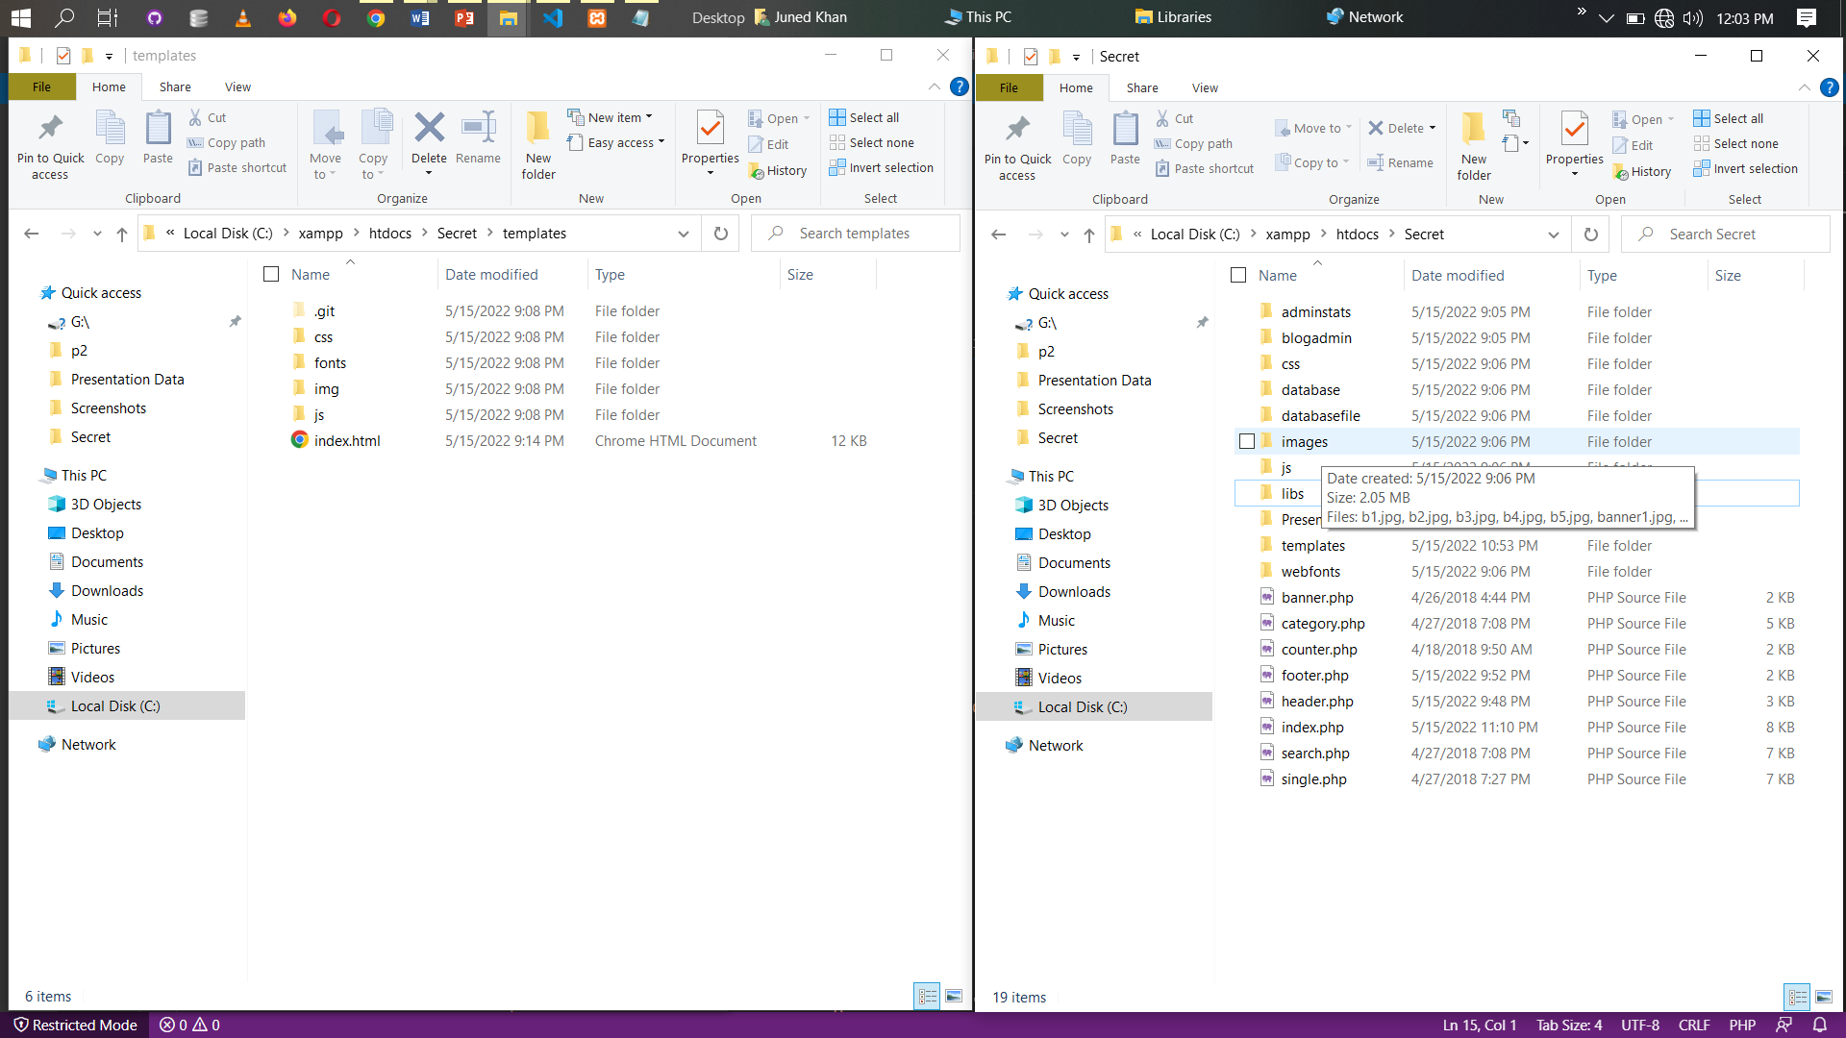6. Website [Source Code](../../Secret)

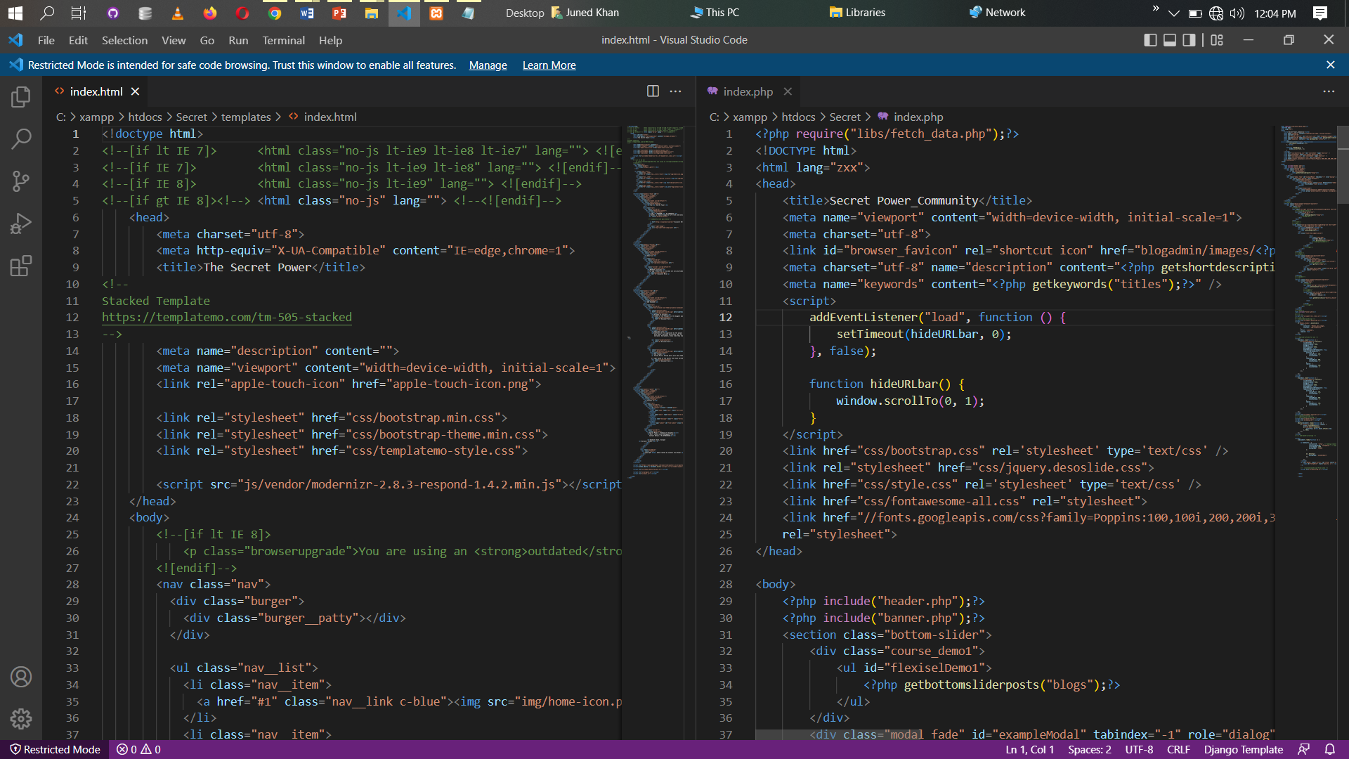

### Chapter 5. Research Methodology

* **Research Conceptual Clarification**: Write about Definition & concept of research methodology in short, Also add steps involved in research methology etc.
* **Research Design**(Research Type): For example – Descriptive research, Exploratory research etc.
* **Statement of Problem** (If any)
* **Research Hypothesis** (If Any)
* **Sources of Data Collection:** For example – Primary Data, Secondary Data
* **Data Collection Instruments:** For example – Questionnaire
* **Sample Description:** Sampling Design, Sample Size, Sampling Method, Sampling Unit etc.
* **Outline of analysis**: a brief outline of tools and techniques to be used for analysis, statistical tools and tests to be used

**Front-End Languages:**

Html

Css

Bootstrap

Java Scrip

**Back-End** **Languages:** PHP

**Database:** SQL

**Tools:** Xampp Control Panel, Chrome Browser

**Services:** Apache, MySql

**Future scope of the Project**

Let's wait for some time we all person want to express what we exactly thought but we don’t have a medium or environment to express our self so that we are building a platform and addict them to express their secret and thoughts now so that they feel better after some years and have fun everyone every future kids will come in our website and said their inner secret without their identity loss.

**Conclusion**

We work for the community & this is all our conclusion.